

**ISTANBUL AYDIN UNIVERSITY**

**SOFTWARE ENGINEERING**

**COMPUTER PROGRAMMING – II**

**ASSIGMENT**

**STUDENT = GOKTUG YILDIZ**

**ID=B1505.090012**

**SOFTWARE REPORT :**

*A-INTRODUCTION;*

Name of programmer: Göktuğ Yıldız

Name of software languages : Java

Operating System : Wimdows 10

Row number of program: 160

*B-BUILD OF SOFTWARE;*

1-The purpose of this program is to take data from files and make console application to calculate some grades of the students also update ,delete infos of students or show the students info to the screen. And make these options a menu for user .That way user can use the program easily.

2- To make these operation in our program we used file readers , file writers , arrays etc.

And for searching ,founding updating etc I used for loop,while loop and arrays together.

2.1- User shoud enter severel things only. They need to choose the option they want to make and enter the ID’s of the students they want to work on.

3- UML Diagram Of The Program ;

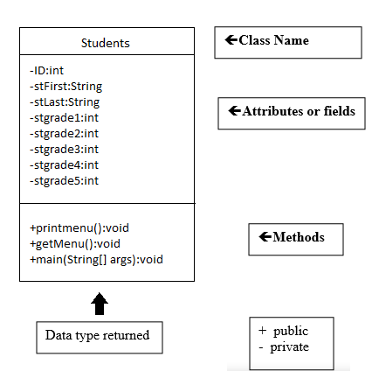

3.1-What can user do with the program;

At the beginning of the program, program shows the user menu with print menu. There are 5 selection to choose in these menu ; 1 show student information ,it will ask the user ID of the student and it will show the user the information of the student that user entered. 2nd one show all students information to user. 3th one is updates the info of the student that user enters.4th deletes the info of the student that user enters and 5th for exit the program

4- To conclude I did this program with file in the java. It was harder to do with java file for me , if I made this program with data base and java it will be much easier for me. There is some missing parts of this program but I could not make them.